Michalowicz M. - Profit First
Notes
- But there is one really friggin’ nagging problem: eight out of ten businesses fail, and the number one reason they fail is lack of profitability.
- The old formula to profit is what’s wrong. It needs to change. You know the formula I’m talking about: Sales − Expenses = Profit. That crusty, bifocal-wearing, old-person-smelling formula at first blush makes total sense. Sell as much as you can, then pay the bills, and what is left over is profit. Here’s the problem: there are never any leftovers. Flap. Flap. Flap. Splat.
- The solution is profoundly simple: Take your profit first.
- The majority of the businesses that survive are racking up debt and their leaders are perpetually stressed.
- Money problems occur when one of two things happen
  - Sales slow down.
  - Sales speed up.
- The perfect size for your business? It will happen naturally, when you take your profit first. You will reverse engineer all the elements of your business, and as Fried says, "the right size will find you.”
- So why are entrepreneurs programmed to pursue bigger and bigger and bigger? Because of an assumption that at a certain point all that revenue will yield a profit.
- Profit must be baked into vour business. Every day, every transaction, every moment. Profit is not an event. Profit is a habit. Do you know the saying "Revenue is vanity, profit is sanity, and cash is king”.
- Sustained profitability depends on efficiency. You can't become efficient in crisis.
- The particulars are updated regularly, but the core system remains the same: Start with sales. Subtract direct costs (the costs you directly incur to create and deliver your product or service). Pay employees. Subtract indirect costs. Pay taxes. Pay owners (owner distributions). Retain or distribute profit (the bottom line).
- We do everything we can to make the top line (revenue) grow so that something, anything, will drip down to the bottom line. It becomes a relentless cycle of chasing after every shiny object disguised as opportunity.
- Frankenstein is a scary parallel to the extremes of entre preneurship. Monster businesses have killed marriages, torn apart families. and for some entrepreneurs, decimated any hope for the good life.
- Principles:
- Parkinson's Law: Why Your Business Is Like a Tube of Toothpaste
You see the more we have of something, the more of it we consume. This is true for anything: food time, even toothpaste.
When you
have less, you do two things. The first is obvious: you become frugal. But something else, far more impactful happens: you become extremely innovative and
find all sorts of ways to extract that last drop
of toothpaste from the tube.
If you first extract your profit and remove it from sight, you'll be left with a nearly empty toothpaste tube to run your business. When less money is available to run your business, you will find ways to get the same or better results with less. By taking your profit first, you will be forced to think smarter and innovate more.
- The Primacy Effect: Why the First Part of Profit First Matters
The principle is this: We place additional significance on whatever we encounter first.
When profit comes first, it is the focus and it is never forgotten.
- Remove Temptation: Once You Take Your Profit First, Put It Away
- Enforce a Rhythm
- But if I set aside my profits, how will I grow?
What I've found is that the fastest, healthiest growth comes from businesses that prioritize profit. And it is not because they plow money back into their businesses. Busi- nesses that plow back their profits aren't truly profitable: they are just holding money temporarily (feigning profit), then spending it, just like any other expense.
To grow the biggest and the fastest, vou need to be the best at one thing vou do. And to become the best at something, you need to first determine what you are best at and do it a whole lot better. To get there, you take your profit first and the answers to being the best at something will reveal themselves.
- And we start with a simple new Profit First formula
Sales - Profit = Expenses
- Here's how you apply the four principles
- Use Small Plates: When money comes into your main INCOME account, it simply acts as a serving tray for the other accounts You then periodically disperse all the money from the INCOME ac- count into different accounts in predetermined percentages. Each of these accounts has a differ ent objective: one is for profit, one for owner compensation, another for taxes and another for operating expenses.
- Serve Sequentially: Always, always allocate money based upon the percentages to the accounts first. Never, ever, ever pay bills first. The money moves from the INCOME account to your PROFIT account,OWNER'S COMP,TAX, and OPEX (OPERATING EXPENSES). Then you pay bills only with what is available in the OPEX account. No exceptions.
And if there isn't enough money left for expenses? It means that your business
is telling you that you can't afford those expenses and need to get rid of them.
- Remove Temptation: Move your PROFIT account and other "tempting" accounts out of arm's reach.Make it really hard and painful to get to that money, thereby removing the temptation to "borrow" (i.e., steal) from yourself.
- Enforce a Rhythm: Do your allocations and payables twice a month (specifically, on the tenth and twenty-fifth). Don't pay only when there is money piled up in the account.
- Right now I want you to set up your PROFIT account.
After setting up this new checking account at your bank, nickname the account PROFIT, and from this moment forward from any deposit you put into your normal checking account, transfer 1 percent of that
leposit into your PROFIT account. Then proceed with your business and processes and money management as you have in the past. Just add to the PROFIT account, and never touch it (until you get to the section of this book where I explain what to do with it).
Something magical will happen. You will start proving the system to yourself.
- Here are the five checking accounts you need to set up:
- INCOME
- PROFIT
- OWNER'S COMP
- TAX
- OPEX
Make sure you set these up as checking accounts for flexibility.
- To keep the money that you allocate and reserve for tax and profit out of your sight. Because when something isn't available to consume, you don't consume it.
- At the second bank set up two savings ac- counts (this is where you will collect interest because your money will pool for a while) The two accounts are PROFIT HOLD and TAX HOLD.
- When choosing your banks, focus on convenience options for primary and inconvenience options for the secondary.
- The instant assessment:
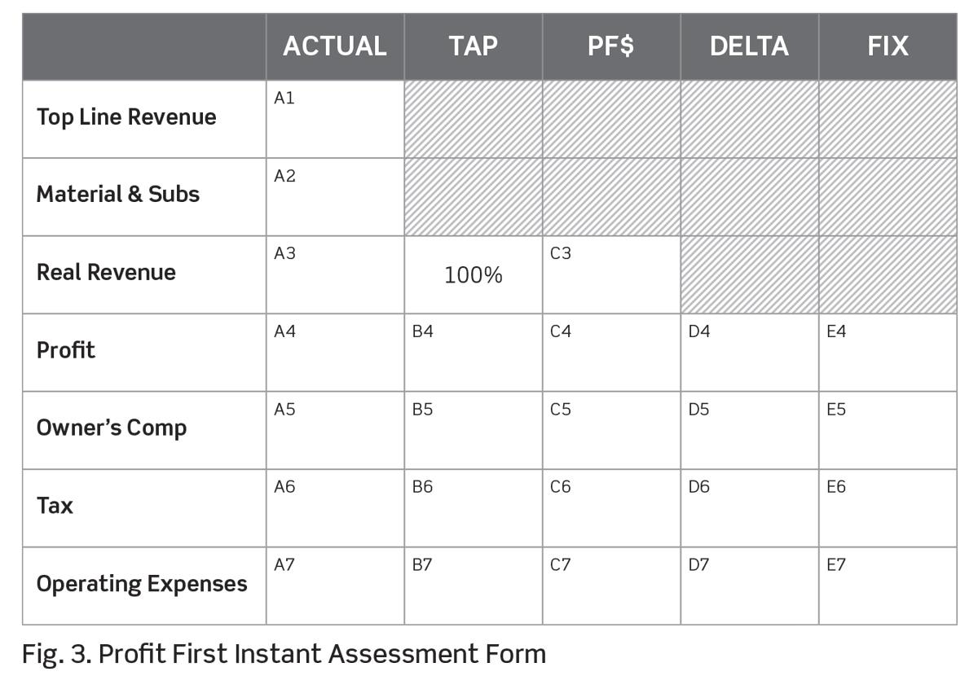
  - In the Actual column, cell A1 enters your Top Line Revenue for the last twelve full months.
  - Your Real Revenue number is the real money your company makes. For the other stuff-subs materials, etc.-you may make a margin, but it isn't the core driver of profitability because you have little control over it. (A3 = A1 - A2)
  - Write down your actual profit from the last twelve months in the Profit cell A4.
  - In the Owner’s Comp cell A5, put down how much you paid yourself (and any other owners of the business) these past twelve months in regular payroll distributions, not profit distributions.
  - In the Tax cell A6, put down how much tax your company has paid on your behalf. This is critical: This is not how much you have paid in taxes.
  - In the Operating Expenses cell A7, add up the total expenses your business paid for the last twelve months. Everything except your Profit, Owner’s Comp, Tax, and any materials and subcontractors that you have already accounted for.
  - Double-check your work by adding up your Profit (A4), Owner’s Comp (A5), Taxes (A6), and Operating Expenses (A7) to see if you get your Real Revenue number (A3). If you don’t get this number, something is off.
  - Next, enter the Profit First percentages in the TAP column based upon your Real Revenue Range (fill in cells B4 through B7).
TAPs = Target Allocation Percentages.
TAPs are not your starting point; TAPs are the targets you are moving toward. (Take them from the following table)
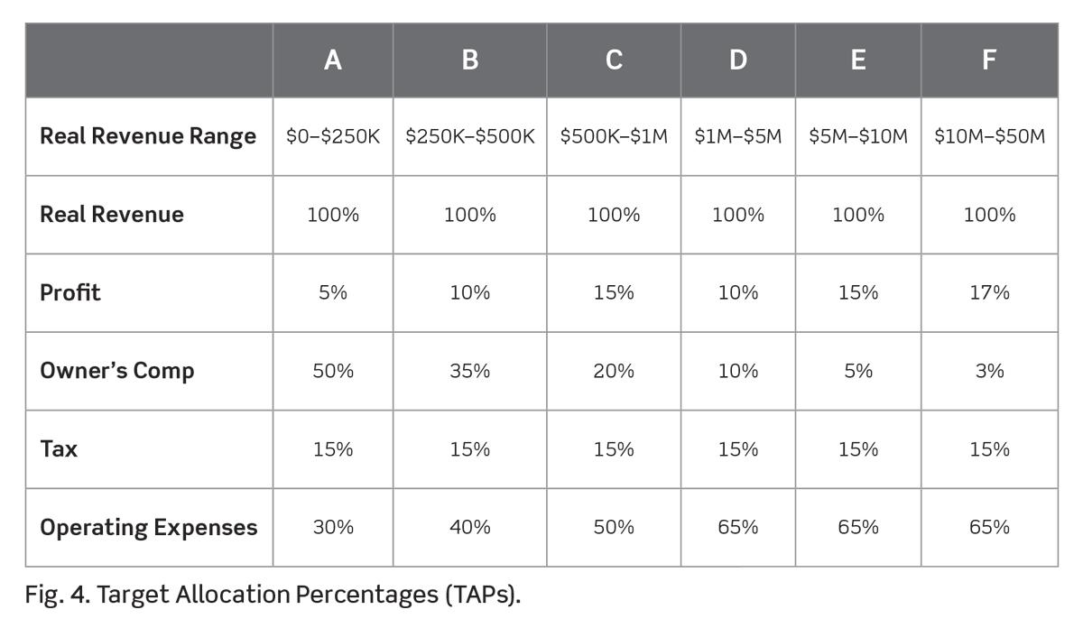
The numbers in this figure are typical ranges that I have found while working with count- less companies over the years and in run- ning my own. And they represent what I have found to be very healthy numbers.
  - In the PF $ column, copy the Real Revenue number from your actual column (cell A3) to the PF $ Real Revenue cell (C3). Then multiply that Real Revenue number by the TAP for each row and write down the number in the corresponding PF $ cell.
  - In the Delta column, take your Ac- tual number and subtract the PF $ number.* This is very likely to result in a negative number for Profit or Owner's Comp or Oper- ating Expenses or all three. It is your Delta, the amount you need to make up.
  - The final column (cells E4 through E7), Fix, will have no numbers, only the word increase (if negative Delta) or decrease (if positive Delta) next to each category.
- The Instant Assessment brings clarity fast. and it can be a rude awakening. No more putting things off.
- A financially healthy company is a result of a series of small daily financial wins, not one big moment. Profitability isn't an event, it's a habit.
- A series of principles I used to start my businesses. Chief among these principles was frugality.
- It wasn't how muck I was spending on expense line items. The problem was, I shouldn't have been spend ing anything on some of those line items.
- You are no longer asking, "How can I make my business big ger?" You are asking, "How can I make my business better?”.
- How does Profit First work if vou iust launched your business and have no revenue?
- Simply use the percentages in the Instant Assessment for your target allocations, but start at 1 percent allocation for the PROFIT account. 50 percent for OWNER'S COMP, and 15 percent for the TAX account.
- No matter what the number is, if you work toward it and believe it's a possibility, you will not only achieve it, you will blow past the "reasonable" numbers others have set.
- Common problems:
  - Don't Get Bogged Down in the details.
  - Look Before You Leap
- Current Allocation Percentage (CAP) is where your business is today. This is the number you will adjust slowly but consistently over time to get closer and closer to the TAPs. (Note: don't just jump to TAP, but maybe move couple of percentages per quarter)
- If you want specific target numbers you need to do a little bit of research:
- Research public companies in your industry or a similar industry. Do a quick Internet search using the term financial market overview, and vou will find dozens of Web sites that report the financials for public companies.
For our purposes, look up the income statements for the last three to five years.
- Review your tax returns for the last three to five years and determine your most profitable year-based on percentages.
- Or, the easiest way, just pick your profit percentage number based on your projected revenue for this year, using revenue for the last twelve months.
- Super high profit percentages are not sustainable. If you can pull off consistently fat profits your competitors will figure out what you're doing. Then, to get more business, they will drop prices. When that happens, you will have to drop prices, too, in order to stay in business.
- You are your best, most important employee. We must take care of you.
- You can't live ond a minimum wage or less. Say it again, once more with feeling: my business serves me; I do not serve my business. Paying yourself next to nothing for hard work is servitude. Always start with CAPs--where you are now-anc increase by 1 percent each quarter.’
- The bottom line is this: don't cut your salary to make the numbers work. The goal of every business is health, and that is achieved through efficiency. Your martyr syndrome is not doing anyone any favors; making yourself the sacrificial lamb does not promote efficiency; it hinders it.
- The Tax plate, so we are clear, is designed to pay the direct Tax liabilities of the business and (this is the big one), the personal income taxes of the owners. Let me say that again because this often gets missed: your company (assuming you own it) will reserve your personal income tax liability for you and then pay it.
- If the tax rate is 35 percent again, for U.S. citizens with higher levels of income), why would I only reserve 15 percent for taxes (as noted in the Instant Assessment I shared earlier)?
  - [Note] because you're taxed on REVENUE - OPEX
- DAY ONE
- Tell Your People
- If you have a progressive accounting pro- fessional, she will be all over Profit First. ([Explain how to deal with accountants that don't want to follow Profit First]).
- Most accountants using the old GAAP method of cash management are lucky to have a handful of profitable clients.
- Set Up Your Accounts
- Five accounts at your primary bank (INCOME, PROFIT, OWNER'S COMP, TAX, and OPEX) and the two accounts at your new no-temptation bank (PROFIT HOLD and TAX HOLD)
- Add to the nickname for each account by adding the CAP next to the account name and also put your TAP in parenthesis. (e.g. "PROFIT 8% (TAP 15%).”)
- Make Your First Distributions
- Even if our targets are much higher, we start with what we've got, plus 1 percent for Profit, Owner's Comp, and Tax We then reduce the Operating Expenses by the cumulative of the percentage adjustments we made to the other three accounts Why start with small percentages, when we likely could do more? The primary goal here is to establish a new automatic routine for you.
- Our First Day, Our First Celebration

  - I wouldn't invest in the advice of someone who isn't taking his own advice.
  - Whenever there is any sitting around and they aren't sure whether those dollars are considered Owner's Comp or Profit. The answer is simple: all of it is Owner's Comp and none of it is profit.
  - You know that saying "Today is the first day of the rest of your life.' I love it. To me, it represents the profound realization that we can change our lives (and our businesses) in a moment. Now is the time.
- WEEK ONE: CUT EXPENSES
  - Increasing sales is very doable and is the key for colossal profitable growth.
  - Cutting expenses is generally a very quick process and is usually very easy. From all the businesses I have met, it is pretty easy for most of them to cut 10 to 20 percent of expenses overnight, such as friv- olous costs.
  - You can easily find your first 10 percent in cuts by doing the following
- Cancel whatever you don't need to help your business run efficiently and keep your customers happy.
- Negotiate every remaining expense, except payroll.
- TWICE A MONTH: THE TENTH AND TWENTY-FIFTH
  - Pay expenses twice a month, on the tenth and the twenty-fifth (or the business day prior if the tenth or twenty-fifth fell on a weekend or holiday).
  - Here's how to get started:
    - Step One: Deposit all revenue into your INCOME account.
    - Step Two: Every tenth and twenty-fifth day of the month, transfer the total deposits from the prior two weeks to each your "small plate" accounts based on your CAPs.
    - Step Three: Transfer the full account bal- ances for both your TAX and PROFIT accounts to the respective accounts at your second (no-temptation) bank.
    - Step Four: Take only what you have allocated as your biweekly salary, and leave the rest to accumulate.
    - Step Five: With the remaining money in the OPEX account, pay your bills. Leave the remaining money in the account.
- QUARTER ONE
  - You are about to take your very first-ever quarterly profit distribution check.
  - Don't confuse the profit distribution with Owner's Comp, which is pay for working in the business. Profit is a reward for owning the business. Just as you get a profit distribution when vou own shares in a public company, for which you didn't do squat workwise, so you get a piece of the profit from your own company.
  - The calendar quarters of every year are as follows:
    - Quarter 1-January 1 to March 31
    - Quarter 2--April 1 to June 30
    - Quarter 3-July 1 to September 30
    - Quarter 4October 1 to December 31
  - On the first day of each new quarter (or the first business day afterward), you will take a profit distribution (no matter when you started with profit first). Remember, the PROFIT account serves a few purposes:
- Monetary reward for the equity owners of the business.
- A metric to measure growth.
- Cash reserve for emergencies.
  - Take 50 percent of the money as profit. The other 50 percent remains in the account, as a reserve.
  - If your company has multiple owners, the distributed profit is divided up based on the percentage owned by each equity owner.
  - The key is this: the profit distribution can never go back to the company. You can't use fancy terms like reinvest, plowback, or profit retention.
  - When you take your profit distribution, the money is to be used only for one purpose: for your personal benefit.
  - Pay Uncle Sam
  - Each quarter, you need to evaluate your current percentages and move them closer to your TAPs.
The goal is to never take a step back.
- YEAR ONE
  - If you owe taxes at year-end and don't have the money in your TAX account, this is the one time you can pull from your PROFIT account for a reason other than profit distribution. In fact, you have to.
  - If you have too much money left in your TAX account, congratulations-you can move that money to your PROFIT account and take a profit distribution.
  - Rainy-Day Fund
As your profits accumulate in your PROFIT account, and you only take 50 percent as a profit distribution, the remainder will act as a rainy-day fund.
- TAKE ACTION: GET READY FOR A GREAT YEAR!
  - Step 1: Start a "celebration list": Come up with ideas for how to spend your quarterly owner's distribution.
  - Step 2: Block out the tenth and twenty fifth on your calendar into perpetuity You will need about five minutes to do the core process of checking the balances of your foundational five accounts to see where you stand.
- "The solution to debt is this simple: If you want to get out of debt, you must get more enjoyment out of saving your money than you do spending your money”.
- The only way you will be able to make this work forever is if you get immediate pleasure each time you exercise your new habits.
- The trap we fall into is believing our most recent best month is our new normal. Then we start running the business according to that "normal.”
- To prevent shortsighted behavior but stay optimistic, always look at your twelve month rolling average income (and related numbers). When comparing figures, compare your current month to the same month in the prior year. Comparisons and rolling averages will give you a much clearer picture of where you truly stand.
- Debt freeze:
- Print out your current income statement for the last twelve months, as well as your current accounts payable report, your credit card statements, loan statements and any other statements related to debt.
- Mark the expense with a P for any expense that directly generates (P)rofit; R for any expense that while necessary, can be (R)eplaced with a less expensive alternative or U for any expense that is (U necessary for delivering your offering.
- Review everything.
- Circle any expense that is recurring.
- Add all the expenses for the year.
- Determine the difference between your current monthly operating expenses and the number it must be according to your Instant Assessment (10% below actually).
- Start by cutting the U expenses first. Then find ways to reduce the R expenses with replacements or alternatives. And evaluate the P expenses to see if you can structure the expense more favorably.
- Evaluate your staff members. If they aren't a P rating, they need either to be moved within your business to help it become more profitable, or they may need to be removed from the company. Now it is time to plan the layoffs.
- Absolutely do not ask people to take a pay cut.
- Here's what can wait for one more day: that purchase you were planning to make today.
- Small, repetitive, continuous actions chained together, build momentous momentum (say that one ten times fast).
- In his extraordinary book, The Tota Money Makeover, Dave Ramsey explains the Debt Snowball.
- Achieve greater efficiency first, then sell more, then improve efficiencies even more and then sell even more.
- How do you get two times the results with half the effort? Effort is the financial cost and time cost. Letting go of clients who suck us dry and eat up our profit margins is a way of making space for clients we can serve exceptionally well by doing what we do best and with fewer resources.
- The top quartile of clients generated 89 percent of the total revenue, while the lowest quartile only accounted for a meager 1 percent of total revenue.
Each group of clients required pretty much the same amount of effort (cost and time).
Those clients are costing you money (negative profit). Get rid of them. Fast!
- Pareto's principle also applies to your clients, in that 20 percent of them yield 80 percent of your revenue. It goes further -80 percent of your profit is derived from 0 per cent of the products and/or services you offer.
- When you start adding new accounts to suit your unique needs, consider yourself an advanced user of Profit First.
- Don't implement this stuff until you have completed at least two full quarters (180 days, plus) with the core stuff you learned about Profit First.
- Here are the additional accounts, contingent on your business needs, that I recommend you consider opening:
  - The Vault: an ultra-low risk, interest-bearing account that you can use for short-term emergencies.
Every business should have a three-month reserve meaning that, if not a single sale came in, all costs could still be covered for three months (a quarter). The question isn't whether you will have a dark day. The question is, when? The Vault is there for that.
You must also establish certain rules for its use: instructions written in advance on
how to proceed.
  - Stocking Account: account for big purchases and to fund the stocking of your inventory.
  - Pass-Through Account: Some businesses receive income from customers that is not to be allocated for Profit or Owner's Comp (e.g. travel reimbursement).
  - Materials Account: If most of your revenue (as indicated in the Instant Assessment) falls into top line revenue and does not flow through to Real Revenue, set up a MATERIALS account for the money that is allocated specifically for purchase of materials.
  - Subcontractor/Commission Accounts: set this up If your business does not purchase materials, but uses contractors or people paid on commission instead.
  - Employee Payroll Account
  - Equipment Account: this account is for big purchases you may need to make further down the road.
  - Drip Account: This account is for retainers, advance payments, and prepayments on work your company will complete over a long period of time and for which vou have vet to expend resources. (put the revenue in Drip Account, and every period transfer to Income Account Divide the total revenue by number of periods).
The DRIP account will help you manage the true cash flow of earned money so that you can manage your expenses and costs.
  - Petty Cash Account: Set up a bank account and get a debit card for petty cash purchases, such as client lunches. Then allocate a regular dollar amount from your OPERATING EXPENSES account to petty cash.
  - Prepayment Account: an account specifically to set aside funds for prepayments so you can take advantage of prepayment deals when they are available (e.g. a discount if you pay for a year of service, rather than a month).
  - Sales Tax Account: if your business collects sales tax, every single stinkin' penny of the sales tax you collect is immediately allocated to this account.
Sales tax isn't even legally your money; you are just acting as a collection agent for the government, so never, ever treat that money as income.
- Create a single-page document that defines the function of each account. Explain what purpose each account serves, and the process you will follow.
- Focus or your Required Income for Allocation (RIFA): This is the money you need to deposit by the tenth and again on the twenty-fifth to have a healthy business, to pay the salary you want from your business, and to take the profits you deserve. Period.
- The grand total of all your accounts shows you all the money on one big plate again-exactly the thing we want to avoid. Looking at a grand total messes with your mind, so don't do it.
- Raising money is a risky endeavor. I generally discourage it, unless you have an extremely high confidence that an investment of money will bring in a lot more profit. How do you know if an investment will bring in more profit? You will know only if you are already profitable. Be profitable first and when vou know what exact elements of your business are making that profit, you can consider using outside money to amplify what is working.
- If you do raise money, set up another account: OUTSIDE CAPITAL.
- For each full-time employee your company should generate Real Revenue of $150,000 to $250,000 (ideally more but this is the minimum).
- Mini power tactics:
  - The Government Money: Owing more taxes than we have money to pay means that at a minimum we'll be paying interest and possibly penal ties on the amount we owe. A smart tactic is first to move this account to a third-party bank that you don't see, and then change the name of the TAX account to THE GOVERNMENT'S MONEY.
  - Hide Accounts: Some banks allow you to "hide' accounts so that vou can't see them on first view when logging onto online banking. Try hiding all of your accounts except for the OPEX account.
  - Outside Income Accounts: set up all your outside income accounts so that any income is trans- ferred to your main INCOME account on a daily basis.
  - Account Snapshot: To keep track of your accounts, set up automatic notifications for your key accounts via email or text.
  - Bank Checks: Rather than pay with checks you write by hand and mail (if you don't lose the envelope on the floor of your car), pay with bank checks.
- 'When you make enough money, you don't have to budget.’
- The ultimate goal of the Profit First lifestyle is financial freedom, which I define as doing what you choose to do whenever you choose to do it.
- If you are carrying debt, I want you to cut up your credit cards. Remember, it's much easier to go with human behavior than it is to fight it, so removing temptation is the best solution.
- “My interest rates will go up!"
To that I say, "Who cares?"
The goal here is to remove financial stress from your life by eradicating debt, not to get better rates on more debt. We can worry about improving your credit score once you are debt free.
- We have a far greater desire to avoid losing something than we have to acquire something. This behavioral response is called loss aversion.
- I realized that no one gives a crap. 99.99 percent of the people who know you or know of you won't care what you own or where you hang out or what your circumstances are.
- Take 99 percent of your profit disbursement and use it to pay down debt (smallest first).
- After you've eradicated your core debt credit cards, bank loans, and student loans start using 45 percent of your quarterly profit disbursement to kill remaining long-term debt and keep 55 percent for your splurge item or experience.
- After you own your cars and home outright and have wiped out debt from every nook and cranny of your life, 100 percent of the profit disbursement goes to you. And this time the party had better be legit.
- Once the money you have collected yields more new money every year than you spend in a year, you have achieved financial freedom.
- Rules:
  - Always start by looking for a free option.
  - Never buy new when you can get the same benefit you would if you bought used. (It's used as soon as you buy it anyway.
  - Never pay full price if you can avoid it.
  - Negotiate and seek alternatives first.
  - Delay major purchases until you have written down ten alternatives to making the purchase and have thought through each one.
- The idea of the Wedge is to only gradually (and mindfully) upgrade your lifestyle as your income increases. Every time your income increases, you set aside half of the increase as savings so that you don't expand your lifestyle to, as Parkinson's Law suggests, "use all available resources.”
- This is why I don't gift my kids an allowance. Instead, I set up a job list (a variant on chores) with corresponding pay rates and post it on the refrigerator.
- For kids is to make them appreciate the value of money, learn to manage it, and strip away any sense of entitlement.
- Mistakes:
- Do Profit First alone ([My note] get an accountability buddy)
- Too much too soon.
Starting slowly and moving slowly and de
liberately will still force you to look for ways
to get better and more efficient at what you
do, but you won't be tempted to throw in the
towel on the entire system because the pres-
sure is too great or the task impossible.
- Grow first (and profit later).
The healthiest companies figure out how tc
consistently be profitable first and then do
everything to grow that.
- Cutting the wrong costs.
- “Plowing back” and “Reinvesting”
- Raiding the tax account.
I am not saying you should ever pay more taxes than you need to (tax is just an expense like any other), but do realize that your taxes will grow as your business health does. So don't steal from your TAX account, thinking you won't need that money for taxes. You will.
- Adding complexity
I found a completely unexpected failure point: people think it needs to be more complex. So they just make up rules to add confusion.
Don't overthink it
Don't add complexity. Don't try to "outsmart" the system.
- Skipping the bank accounts
They use a spreadsheet or modify the chart of ac- counts in their accounting system to emulate the Profit First "small plate' bank accounts.
Spreadsheets and your account- ing system's general ledger reports are also great, but they are also too late. You don't look at them when making in-the-moment money decisions; you look at them after the fact. Coming up with a battle plan after the battle is over is useless.
- "The man who can drive himself further once the effort gets painful is the man who will win.”
- The fear of looking stupid or inexperienced wins out over logic, which tells players that the underhand shot will give them a higher success rate.
- Chances are you're still the first of your friends to implement Profit First. And just as good friends would behave when you are the first to try something new, they might mock you. Welcome to the granny shot of accounting and money management: Profit First.
- The normal response to fixing problems is to try to change our habits.
Changing habits is possible but is also really, really hard. Instead, simple systems that capture the good parts of our habits and guard us from the bad parts will bring about positive and permanent change, fast.
That's all Profit First is - a simple system that works with us as we are.
- [My note] at the end there is a quick setup guide that could be helpful.

